Unit Test Developer

Disiapkan oleh :
Nama | : | Wahyu Agung Utomo
Posisi | : | Engineer Developer
Tanggal | : | 02/10/2024 | Signature

Direview oleh :

Nama | :
Posisi | :
Tanggal | : |  | Signature
Nama | : | <Project Manager>
Posisi | :
Tanggal | : |  | Signature

Table of Contents
Document Information 4
Document History 4
Document Review 4
Action 4
Document Summary 4
1. Requirments 5

Document Control

Document Information
Location | <Insert link to the location where the document is saved>
Owning Team
Contributing Team(s)

Document History
Author(s) | Date | Version | Comments
Wahyu Agung Utomo | 02/10/2024 | 1.0 | Initiate document

Document Review
Name | Position | Action
S = Signed Approval Required, QA, Quality Assurance Review Required, FR = Formal Review Required, IR = Informal Review, I = For Information.

Document Summary
Short Description | Unit Test Blazor To Do List
Related Documents

1. Requirments
Jalankan Aplikasi Local Host
Link Url : https://localhost:7064
- Menu To Do View
Tampilan menu View To Do List
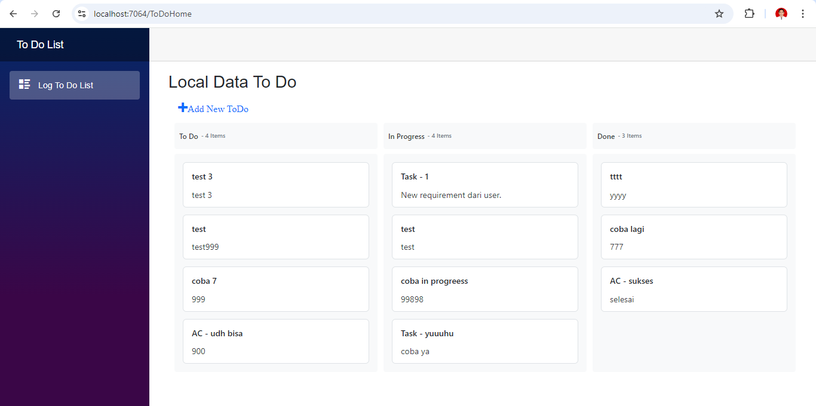
- Add
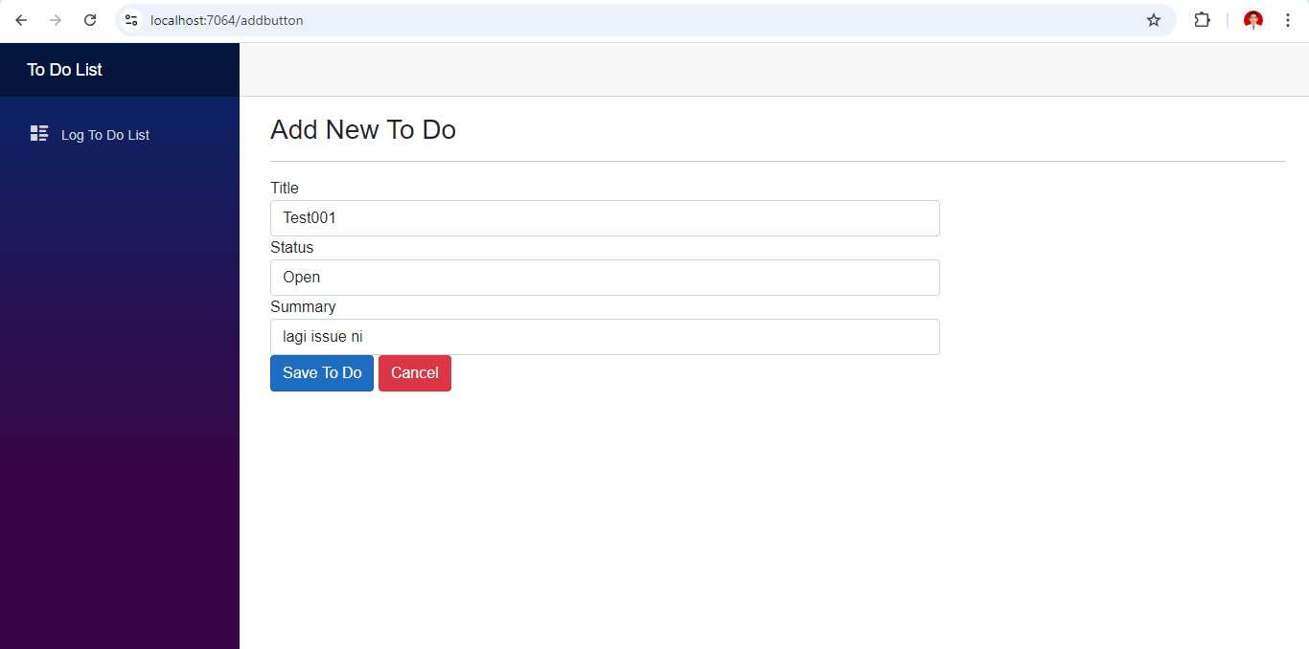
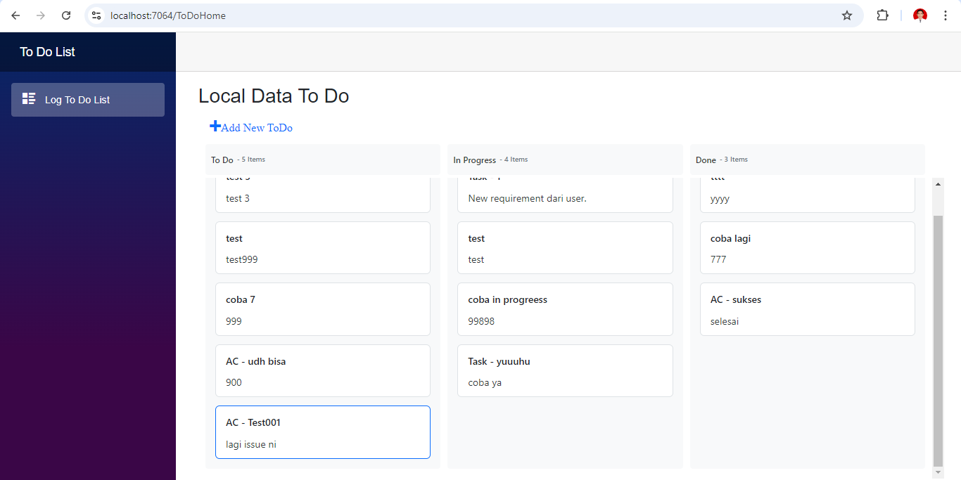

- Edit
Melakukan test Edit dari status “Open” → “In Progress”. Kemudian →Save
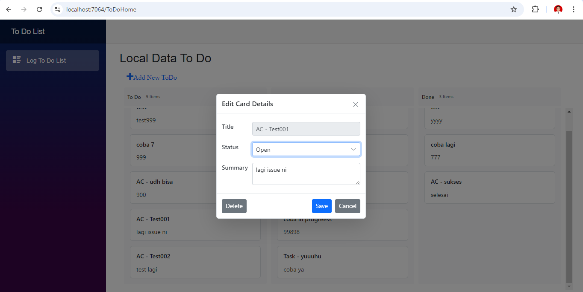
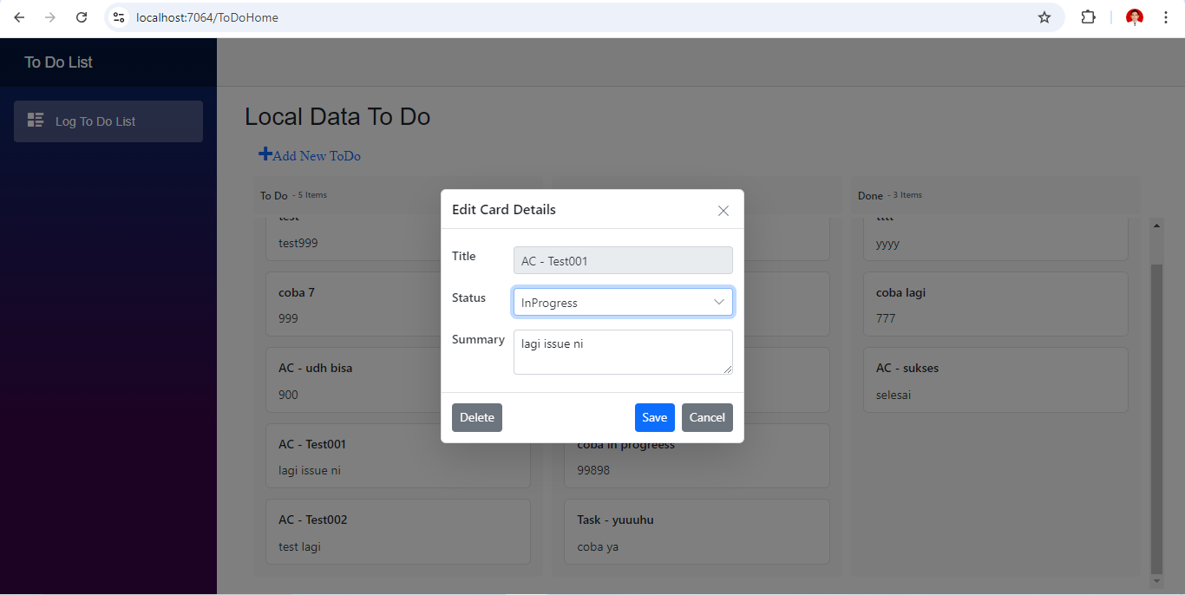
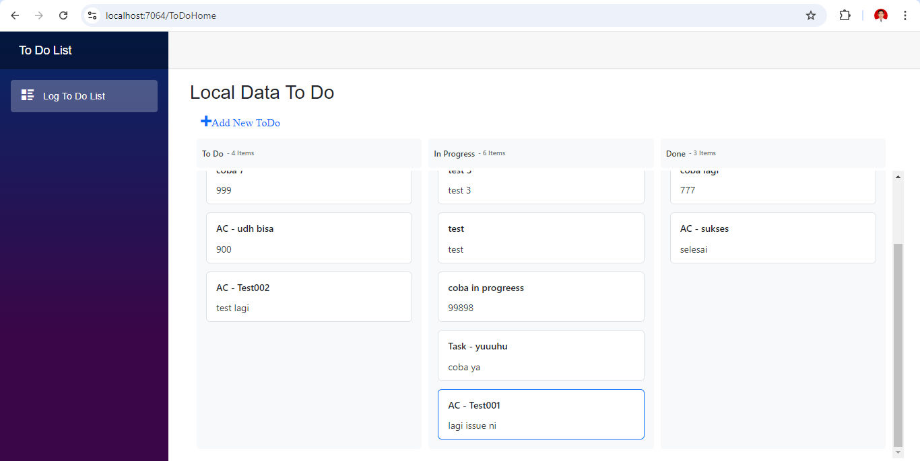
Card Log AC – Test001 sudah pindah ke In Progress
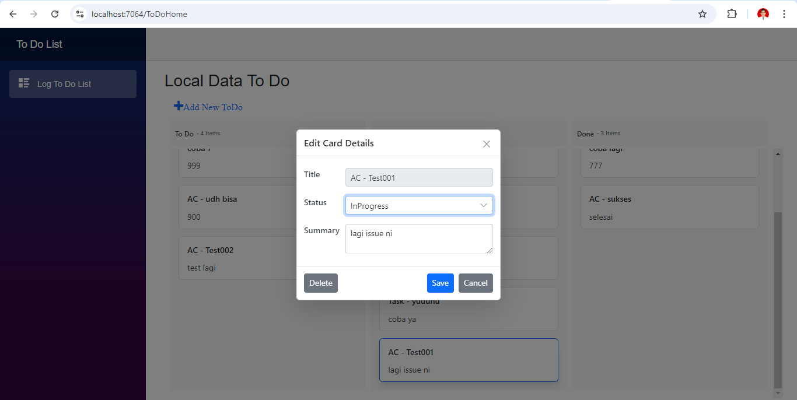

- Delete
Melakukan test Delete untuk Card Log AC – Test001
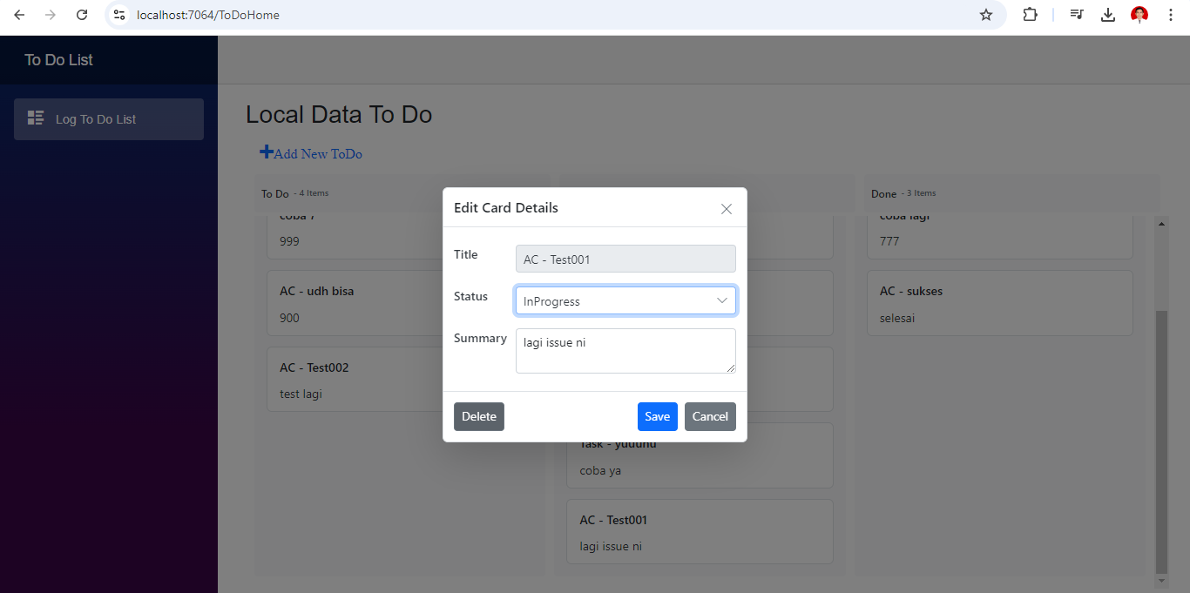
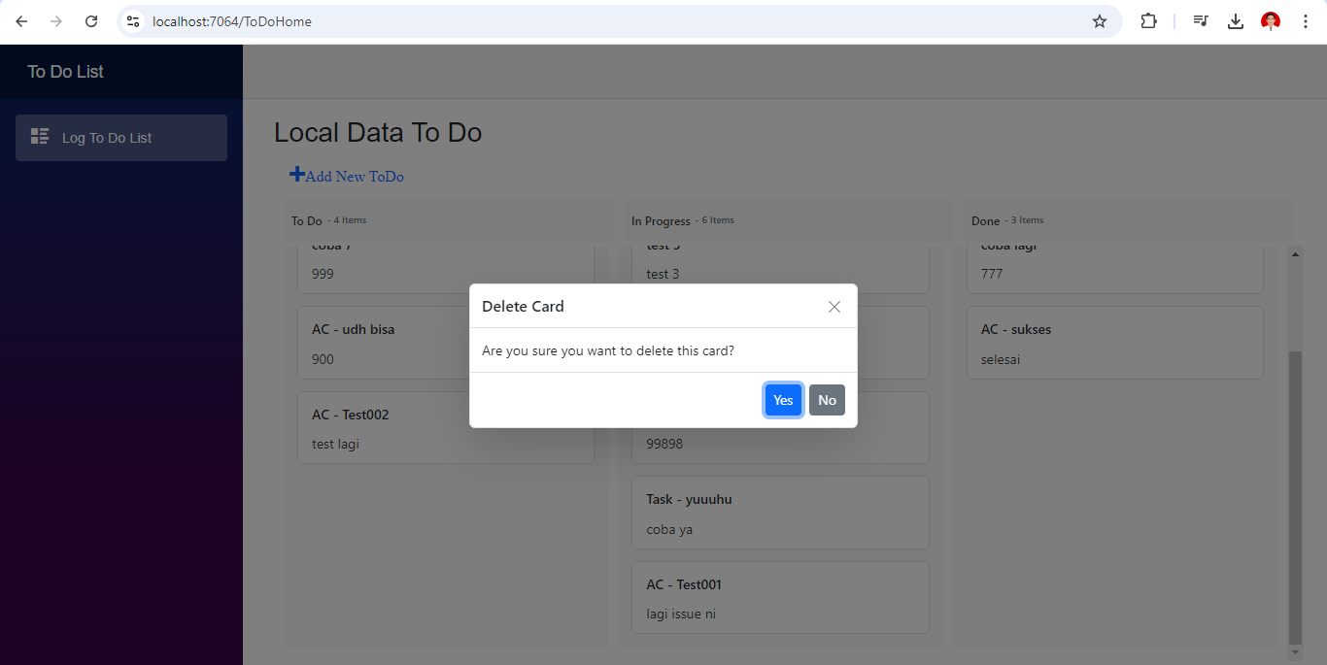
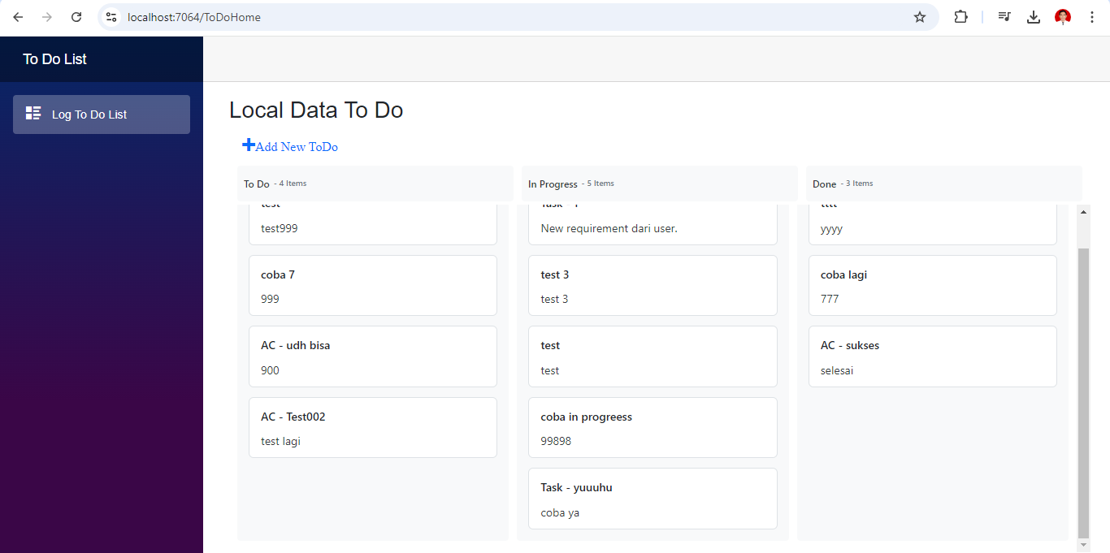
Pada menu Card Log AC – Test001 sudah hilang dari List In Progress.

- Menu In Progress Task - 1 → Done/Close Task → Dan Kembali lagi ke “Open” (jika di perlukan).
